**120A3051**

**Shreya Idate**

**Batch: E3**

**Experiment No: 3**

**AIM**: To Perform various GIT operations on local and Remote repositories.

**THEORY**:

Configuring local username and user-email:

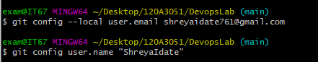

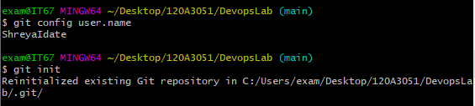

Convert a local directory into a repository:



Add and commit local changes:

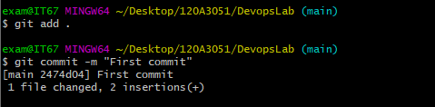

Add a remote:

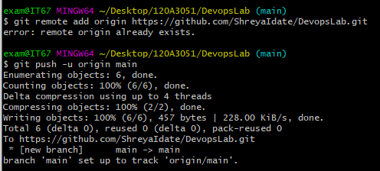

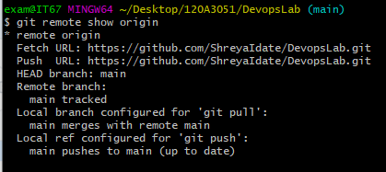

Download the latest changes in the project:

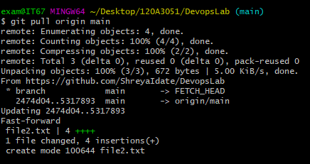

Create a new branch:

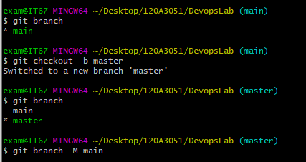

See git log:

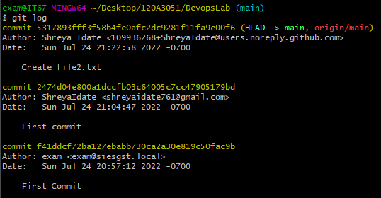

Create a branch and commit new changes:

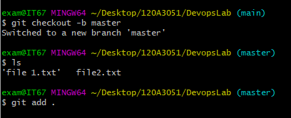

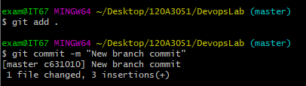

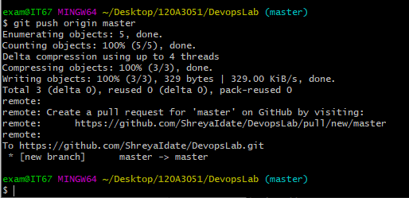

Change branch and Merge the two branches:

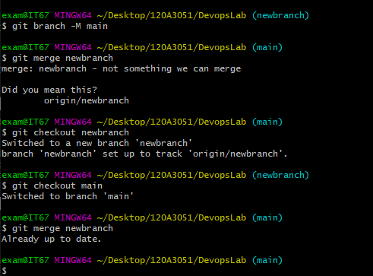

**CONCLUSION: S**uccessfully performed various GIT operations on local and remote repositories.